**Week 5 Early Republic (1)**

**Outline**

1. End of kingship.
2. Magistrates under in the regal period: praetors.
3. Chief officials of the Republic: originally called *praetores*: when the change in name from praetor to consul[1] occurred is **not certain**. Zonaras, Epitome of Histories suggests that this change occurred after the Decemvirate (449 BC); other scholars argue for a much later date (367 BC), at least by 298.
4. Main political issues of 5th and 4th century Rome: often claimed to be the division between patricians and plebeians.

**Termination of kingship in the end of the 6th century BC**

1. Reasons
2. Probably **not** an attempt to get rid of foreign (Etruscan) power (not an expulsion, e.g., myth of Lucretia).
3. Perhaps aristocratic competition led to the termination of kingship[2].
4. Beginning of the Republic
5. Introduction

With the termination of kingship, the Republic came into being, traditionally dated to 509 BC. From this date onwards, Rome was ruled by a board of annually elected magistrates.

1. Sources

In the later sources provided by the Romans themselves, two consuls (chief magistrates) were elected by the *comitia centuriata* to replace the king:

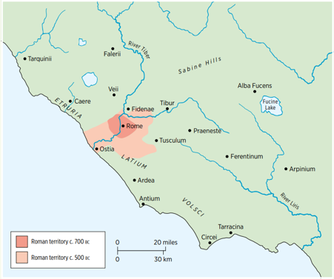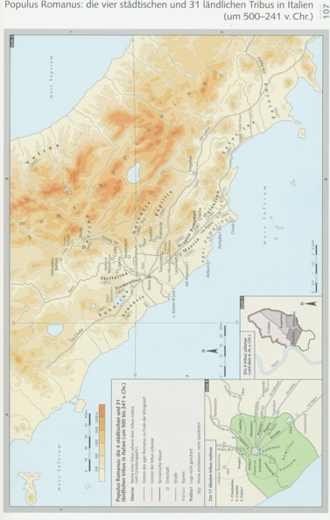 “Lucius Tarquinius Superbus ruled for five and twenty years. The rule of the kings at Rome, from its foundation to its liberation, lasted **two hundred and forty-four years[3]**. Two consuls were then chosen in the centuriate comitia, under the presidency of the Prefect of the City, in accordance with (根据) the commentaries of Servius Tullius. These were Lucius Junius Brutus and Lucius Tarquinius Collatinus.” (Livy, 1.60.4).

**People’s assemblies (in the late Republic)**

|  |  |  |  |  |
| --- | --- | --- | --- | --- |
|  | ***Curiata*** | ***Centuriata*** | ***Tributa populi*** | ***Tributa plebis*** |
| **Composition** | 30 lictors, 1 to represent each *curia* | All citizens | All citizens | All plebeians |
| **Meeting place** | *Comitium* | Campus Martius | Forum or Capitol, except for elections (Campus Martius) | As for *tributa populi* |
| **Structure** | 30 *curiae*, 10 from each of 3 ancient tribes | 193 centuries, of which 18 *equites*, 170 *pedites*, 5 unarmed | 35 tribes, 4 urban, 31 rural | As for *tributa populi* |
| **Presiding officer** | Consul, praetor, *pontifex maximus* | Consul, praetor, dictator, *interrex* | Consul, praetor | Tribune of the plebs or aedile of the plebs |
| **Elections** | None | Consuls, praetors, censors | Curule aediles, quaestors | Tribunes, aediles of the plebs |
| **Legislation** | (under consul) confirm *imperium*; (under p.m.) wills, adoptions, etc. | Not normal after 218, except to declare war | Normal in late Republic | Laws (*plebiscita*) proposed by tribunes |
| **Judicial functions** | None | Capital charges, but rare in 1st century | Serious charges, but later replaced by courts | As for *tributa* *popul*i, but involving the tribunes |

**Magistrates in the Republic**

|  |  |  |  |  |  |
| --- | --- | --- | --- | --- | --- |
| **Magistracy** | **Powers** | **Age of tenure** | **Election** | **Number** | **History** |
| **Dictator (not more than six months)** | Superior to all other offices – 24 lictors |  | Nominated by consul at the Senate’s request | One, with a “master of the horse” below him | From 501. Rare after 3rd century but used by Sulla in 82–1; Caesar in 49–4 |
| **Censor (18 months, every five years)** | Review of senate list; taking of census; “care of morals” | At least middle 40s, often older | Created by consul, after vote in comitia centuriata | Two | Introduced 443; erratic after 86 |
| **Consul (One year)** | Holds major *imperium* home and abroad – 12 lictors | After 180, at least 42 (patricians 40) | Created by consul or dictator, after vote in comitia centuriata | Two, the *fasces* alternating monthly | From early Republic; plebeians admitted 366 |
| **Praetor (One year)** | Judicial duties in Rome; command of armies outside Rome. | After 180, at least 39 (patricians 37) | Created by consul, after vote in comitia centuriata | 1 in 366; 2 in 242; 2 more from c. 230; 8 by time of Sulla; later – 10/14/16 | Introduced in 366, perhaps first as military office, later legal office |
| **Aedile (One year)** | Markets, roads, food supply, archives, annual games | 36 | Plebeian aediles in comitia tributa, presided over by tribune; curule, presided over by consul | 2 plebeian, 2 curule later 2 for food-supply (46); 2 cereales in 46 | 2 plebeian in 496; 2 curule in 366; 2 cereales in 46 |
| **Quaestor (1 year from Dec. 5)** | Assist magistrates with treasury; archives; tax collection; Italy and the provinces – esp. financial | 30 (after 80) | In comitia tributa, presided over by a consul | 4 early Republic; 10 by 197; 20 from 80; 40 under Caesar | Had automatic entry to Senate after Sulla |
| **Tribune of the plebs (1 year, from Dec. 10)** | Propose bills to *comitia tributa*; right to veto acts of magistrates | Unfixed, but often after quaestorship | In *comitia tributa*, presided by a tribune | 10 from 366 | Created by plebs alone in 496 |

1. Consul and praetor
2. Lictors

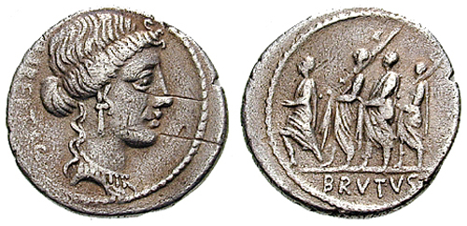The consuls, praetors and the dictator had lictors, symbolising the *imperium* (i.e., power) they had. Lictors carried the *fasces* (a bundle of rods with axe[4]). On the reverse of this coin, you can see some lictors.

1. But the sources also explain to us that the chief magistrates in the early period of the Republic were called *praetores* (sing. *praetor*).
2. “But this interpretation is refuted (驳斥) by the fact that it was **not yet** the custom in those days for the consul to be called ‘judge’, but ‘praetor.’” (Livy, 3.55.12).
3. Praetors existed during the time of the early Republic:

*Twelve Tables*, tab. VIII.4:

“If any persons are in possession of adjoining (相邻的) fields, and a dispute arises with reference to the boundaries of the same, the Praetor shall appoint three arbiters (仲裁员), who shall take cognizance of the case, and, after the boundaries have been established, he shall assign to each party that to which he is entitled” (Cicero, *On the Laws*, 1.21.55).

1. Zonaras (7.19.1) explains that after the Decemvirate (449 BC) the consuls were first called as such; before they were called “praetors”. Ioannes Zonaras (12th c. AD), *Epitome* (Summary) *of the Histories*.
2. The passage by Livy has been taken to mean that in the early Republic there were **three chief magistrates**: *praetor maximus[5]*, but this interpretation is **not necessary**; there may simply have existed a hierarchy between the two *praetores*.

“There is an ancient law, inscribed with old-fashioned letters and spellings, to the effect that whoever was *praetor maximus* on the Ides of September[6] would insert a nail (钉子); the law was attached to the right side of the temple of Jupiter Optimus Maximus[7], on the side facing the temple of Minerva. They say that the nail served, in an age when letters were rarely used, to **mark the passage of years**, and that it was connected with the temple of Minerva because numbers were discovered by Minerva. Cincius, a diligent student of such monuments, affirms that nails as indicators of the years are inserted in the temple of Nortia, the Etruscan goddess at Volsinii.” (Livy 7.3.5-7).

**Key elements of the early Republic**

1. *Libertas* and *consulatus*

Tacitus, *Annals*, 1.1:

“ROME at the beginning was ruled by kings. **Freedom** (*libertas*)and the **consulship** (*consulatus*) were established by Lucius Brutus[8]. Dictatorships were held for a temporary crisis[9]. The power of the decemvirs[10] did not last beyond two years, nor was the consular jurisdiction of the military tribunes[11] of long duration. The despotisms (专制) of **Cinna** and **Sulla** were brief; the rule of **Pompeius** and of **Crassus** soon yielded before **Caesar**; the arms of **Lepidus** and **Antonius** before **Augustus**; who, when the world was wearied by civil strife, subjected it to empire under the title of Prince (*princeps*)*.*”

1. Main political issues of 5th and 4th century[12] Rome
2. A methodological (方法论的) issue
3. 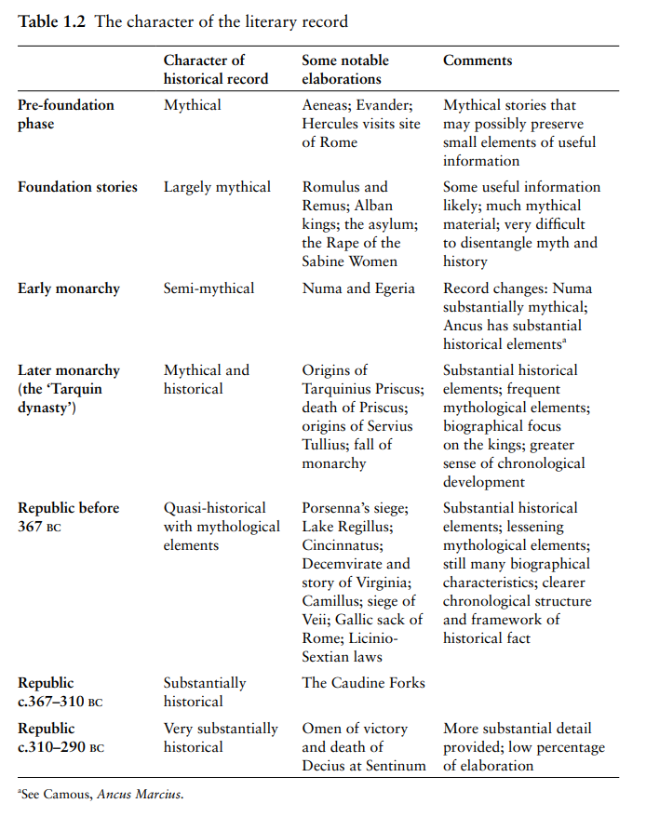The literary sources for this period are styled “quasi-historical with mythological elements” by Guy Bradley, *Early Rome to 290 BC: The Beginnings of the City and the Rise of the Republic* (Ed inburgh 2020) 28.
4. This is a problem, because much of what the literary tradition (e.g., Livy, Dionysius of Halicarnassus, and Plutarch in his *Parallel Lives*) relates about notable events is **steeped in legend**. It is difficult to **isolate historically accurate elements** from the myth.
5. The most secure elements in our literary record that are able to shed light on the most important political issues of 5th and 4th century Rome are references to and texts of statute laws passed by one of Rome’s people’s assemblies, especially those of **antiquarians[13]** as opposed to historiographers/historians who provide **moral instruction** (Potter, p.47).
6. Most laws often matters of **war and peace**, **treaties**, or the bestowal (授予) of a **triumph**. But also, other issues were the objects of votes in the assemblies. Equally secure of the evidence consisting of records of triumphs. Both the records of legislation and of triumphs allow us to gain insight into the expansion of Rome. E.g., the *Fasti Triumphales*, an inscription from 18 BC (Augustus’ time), tells us how Rome expanded.

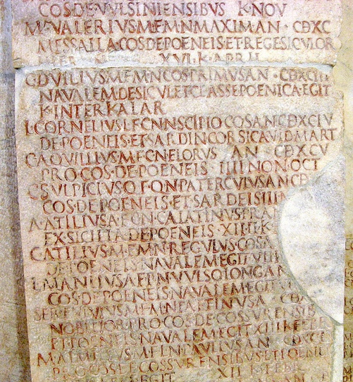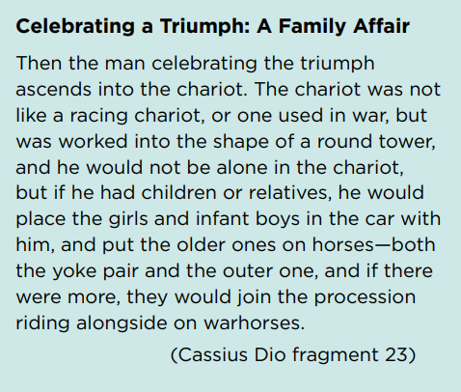p.s., In a triumph, the chariot was drawn by 4 horses.

1. **Division between patricians and plebeians**

The most important political development in 5th and 4th century Rome is often claimed to be the division between patricians and plebeians.

1. Patricians were Roman citizens who constituted **the ruling elite** in early Republican Rome and who belonged to aristocratic families that **claimed descent from Rome’s earliest senators** established by Romulus or **from legendary heroic figures[14]**. Plebeians were all the others.
2. That there was a “struggle” between these two orders might have been the case, but the literary record contains a number of problems.

* The attribution of new developments to one **mythological** character (Romulus) should make us wary (谨慎的).
* Some of the names on the lists of Roman magistrates from the 1st half of the 5th century BC stem from families that were **not** patrician in the later years of the Republic for which we have better evidence.

1. Three explanations of the problems

* The lists were not accurate: non-patrician names were **fakes**.
* “Aberration (偏差) of naming practice” (Potter p.48).
* The individuals stemming from families with non-patrician names were **really plebeian** and held office **before the patrician order had taken full shape**, which possibly occurred after the Decemvirate.

1. Conclusion

The 3rd explanation is most plausible: the patrician order formed only **after** the end of the kingdom.

1. Example of patricians: Sarcophagus (石棺) of **Scipio** Barbatus

* 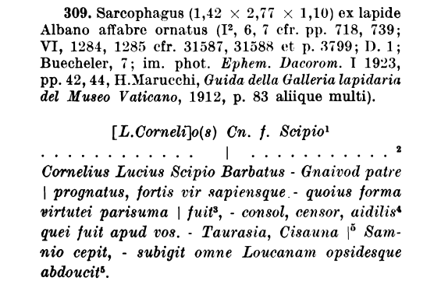[L. Corneli]us Scipio, son of Gnaeus,
* 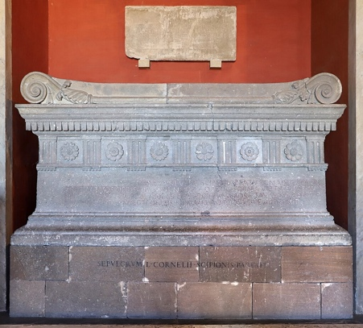Cornelius Lucius Scipio Barbatus, sprung from his father Gnaeus, a brave and wise man, whose **beauty** was very like his **courage**, who was consul[15], censor, *aedilis* among us. He captured Taurasia, Cisauna of Samnium – he subjugated the whole of Lucania, and he led the hostages away.

1. “Consul” is a name used in later Republic.
2. It seems that the last king built many public buildings to consolidate his status and power, which made other elites feel threatened.
3. 753 – 509 BC.
4. Within the *pomerium*, the axe was laid down.
5. *Maximus* means “greatest”, indicating that there would be more than 2 chief magistrates at that time.
6. i.e., 9.13.
7. The chief temple in Rome.
8. It’s old tradition.
9. One could hold for less than 6 months.
10. The decemvirs were a group of **ten** officials in ancient Rome, appointed to draft and enforce the Law of the Twelve Tables around 451-450 BC. They held significant power, temporarily replacing other magistrates, and were known for their authoritarian rule, leading to their eventual downfall.
11. Military tribunes with consular authority comprised a board of **3, 4 or 6** men were elected in some (most) years between 444 and 367 BC **instead of consuls**.
12. The period that is sometimes styled the early Republic, which is defined as the period before Rome started expanding.
13. Scholars in antiquity.
14.
15. He held the consulship in 298 BC.